**DAILY ONLINE ACTIVITIES SUMMARY**

|  |  |  |  |  |  |
| --- | --- | --- | --- | --- | --- |
| **Date:** | | **21/06/2020** | **Name:** | **JASLINE SHARON TAURO** | |
| **Sem & Sec** | | **4th sem, A Section** | **USN:** | **4AL18CS029** | |
| **Online Test Summary** | | | | | |
| **Subject** | **----** | | | | |
| **Max. Marks** | **----** | | **Score** | **----** | |
| **Certification Course Summary** | | | | | |
| **Course** | | Software development engineer | | | |
| **Certificate Provider** | | **AWS Educate** | **Duration** | | **3 hrs.** |
| **Coding Challenges** | | | | | |
| **Problem Statement:**  Write a C Program to rotate a Matrix by 90 Degree in Clockwise or Anticlockwise Direction. Implement (Both the rotations in single program using switch case statement). | | | | | |
| **Status: EXECUTED** | | | | | |
| **Uploaded the report in GitHub** | | | **YES** | | |
| **If yes Repository name** | | | <https://github.com/jaslinesharontauro/C_Prgms> | | |
| **Uploaded the report in slack** | | | **YES** | | |

Online Test Details: (Attach the snapshot and briefly write the report for the same)

Certification Course Details: (Attach the snapshot and briefly write the report for the same)

Coding Challenges Details: (Attach the snapshot and briefly write the report for the same)

CERTIFICATION COURSE DETAILS:

Today I have started the new course “Software Developer Engineer” by AWS Educate. In this course today I learnt about Software development in mobile and gaming and also about programing and scripting of software development. Today I have completed two modules of this course. And I have also completed the assessments of this modules of the course.



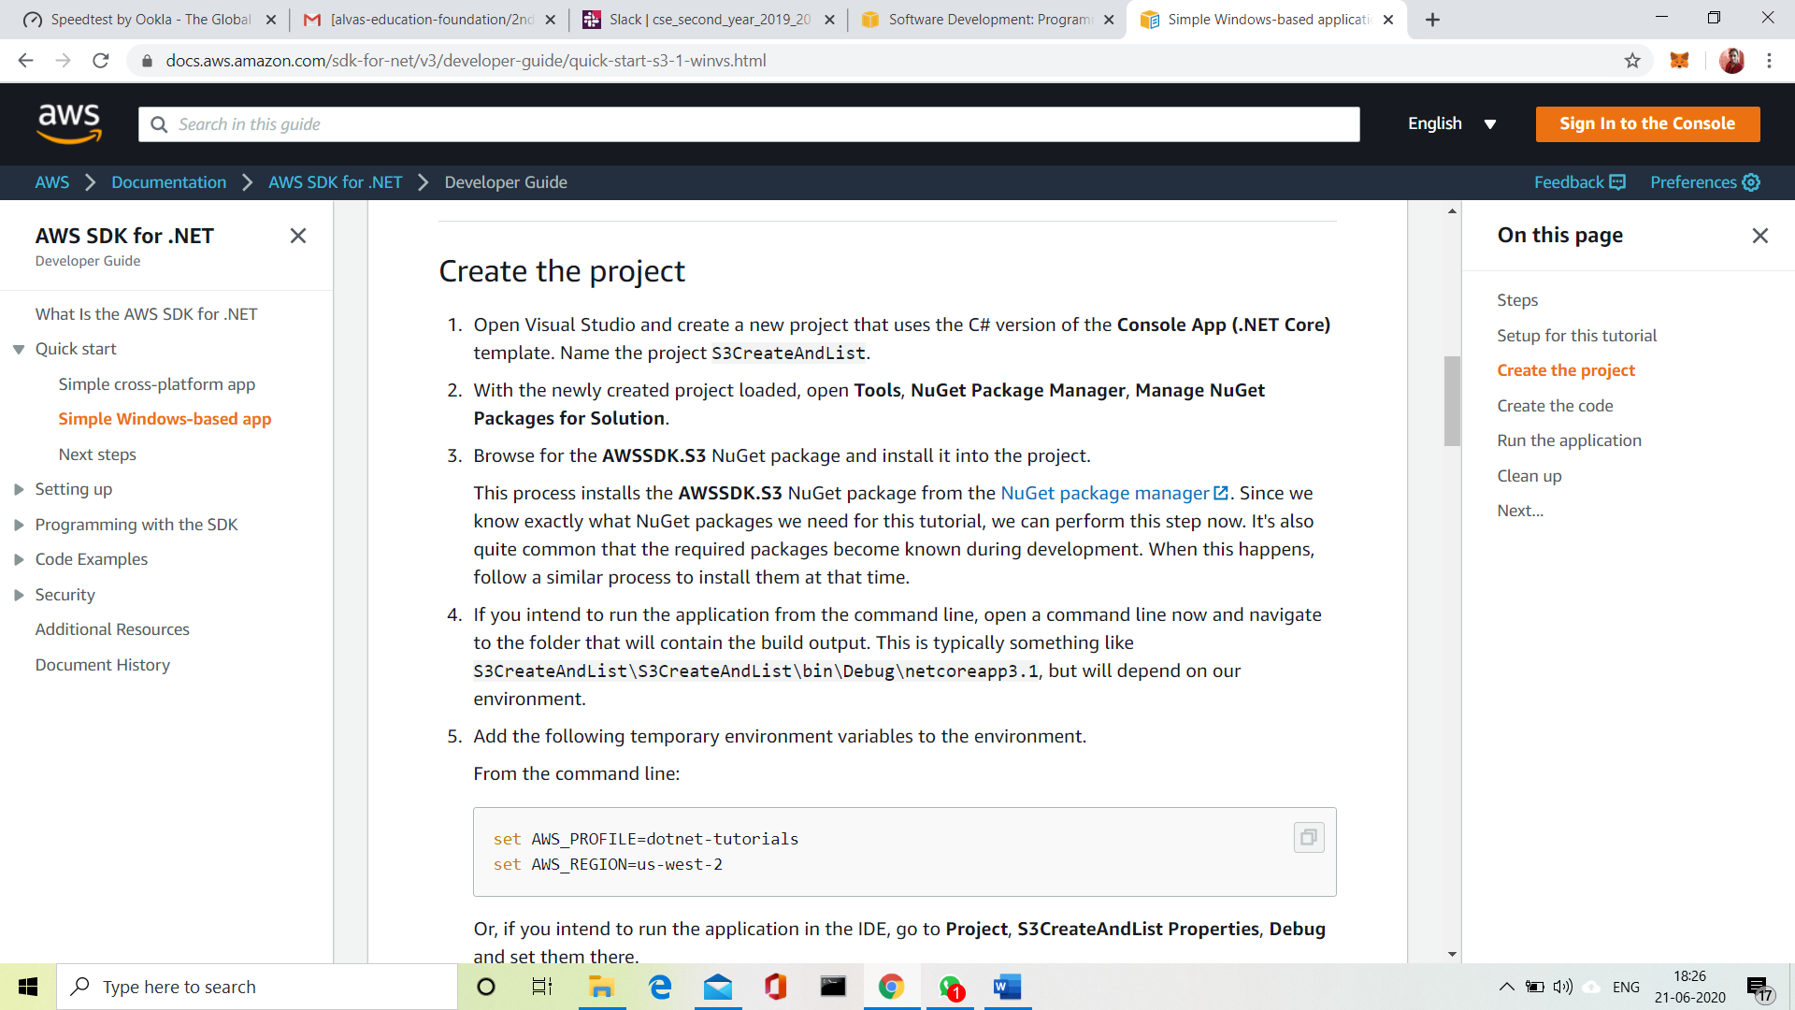

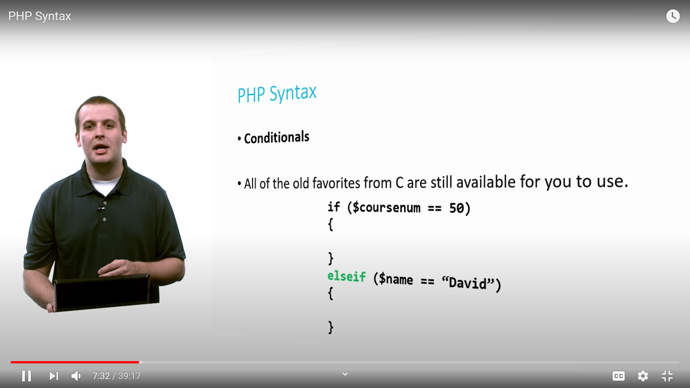

3.CODING CHALLENGES:

Problem Statement 1:

Write a C Program to rotate a Matrix by 90 Degree in Clockwise or Anticlockwise Direction. Implement (Both the rotations in single program using switch case statement).

Matrix Rotation by 90 Degree in Clockwise Direction:

Input:  
Enter the total Number of Rows m: 3  
Enter the total Number of Columns: 3  
Enter the Elements of the Matrix:  
1 2 3 4 5 6 7 8 9  
Output:  
The Given Matrix is:  
1 2 3  
4 5 6  
7 8 9  
The Output Matrix After Rotation by 90 Degree in Clockwise Direction is:  
7 4 1  
8 5 2  
9 6 3

Matrix Rotation by 90 Degree in Anticlockwise Direction:

Input:  
Enter the total Number of Rows m: 3  
Enter the total Number of Columns: 3  
Enter the Elements of the Matrix:  
1 2 3 4 5 6 7 8 9  
Output:  
The Given Matrix is:  
1 2 3  
4 5 6  
7 8 9

The Output Matrix After Rotation by 90 Degree in Clockwise Direction is:  
3 6 9  
2 5 8  
1 4 7

Hint:  
Steps involved in Matrix Rotation by 90 Degree in Clockwise direction:  
⎝ Find the Transpose of the Matrix  
⎝ Reverse every rows of the Matrix

Steps involved in Matrix Rotation by 90 Degree in Anti clockwise direction:  
⎝ Find the Transpose of the Matrix  
⎝ Reverse every columns of the Matrix

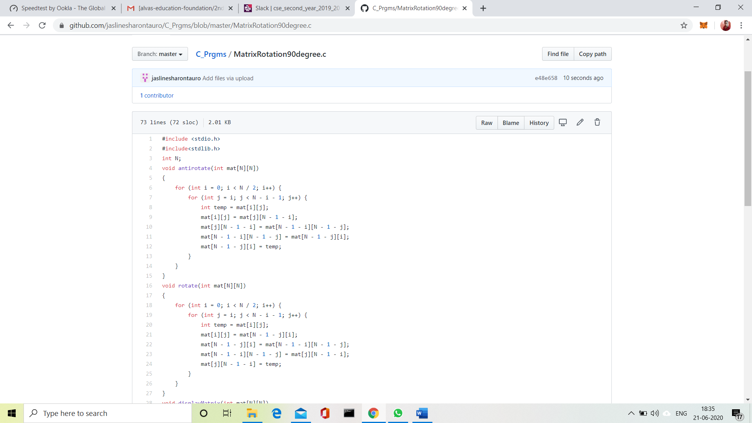

 Solution uploaded in GitHub.